Ultimate Eye Opening
Gut Wrenching Statistics Report

- 87% of INFECTED sites are running Wordpress¹¹.

- In one year, $1 Trillion dollars worth of intellectual property was stolen due to hackers².

- Report finds that 90% of businesses studied were hacked once within a 12 month period and 77% of the same business group were hacked more than once in the same year¹⁰.

- 230 SERIOUS vulnerabilities found on average in ALL websites³.

- 23% of ALL cybercrime happens in the United States of America¹.

- It only takes 10 MINUTES to CRACK a 6 character password⁴.

- Average cost of cybercrime is $5.9 million dollars annually (research studied 50 large companies); 72 successful attacks per week and more than 1 per company⁶.

- Greatest $$$ lost in cybercrimes is through inserting malicious code, denial in service, stolen devices, and web based attacks⁶.

- First juvenile ever sent to prison for hacking was 16 years old. He hacked into NASA computers stealing software worth $1.7 million costing NASA $41,000 in repair⁷.

- Average of 30,000 websites are infected DAILY with malware⁸.

- Information theft is the number 1 cost, followed by business downtime⁶.

- 73% of ALL Americans have been victims of some type of cybercrime⁹.

- 15 year old, "Mafiaboy", a script kiddie cost some of the largest internet vendors $1.7 BILLION in February of 2000⁵.

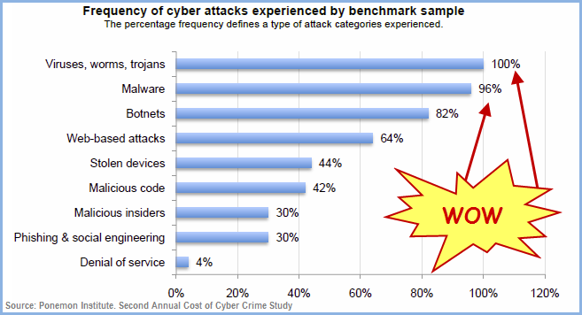
- Frequency and Types of Attacks:

- Types of Consequences and Percentage Cost:
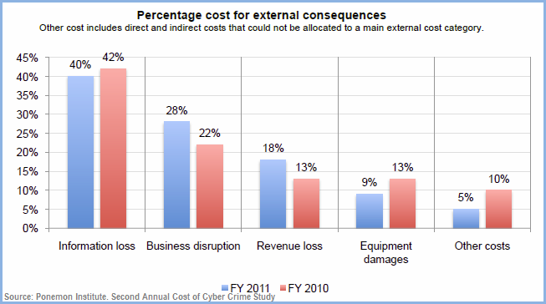

NOTES
¹Europol. Cybercrime: Top 20 Countries by Europol The Center to Fight CyberCrime. http://europol.easyred.com/
²Goldman Russell, Recession Turns IT Workers Into Hackers. ABC News. 2009. http://abcnews.go.com/Business/story?id=7027145&page=1
³Grossman, Jeremiah. Whitehat Security Website Statistics Report; How Does Your Website Security Stack Up Against Your Peers? 12th Edition. 2012.
⁴iSight. Cracking the Code on Password Protection. 2013. http://i-sight.com/corporate-security/cracking-the-code-on-password-protection/
⁵Leeson, Peter. T. & Coyne, Christopher. J. The Economics of Computer Hacking. University Essay. http://peterleeson.com/hackers.pdf
⁶Ponemon Institute. Second Annual Cost of Cyber Crime Study: Benchmark Study of U.S. Companies. ArcSight, HP Company. August 2011.
⁷Sharp, R. Hack Attack Infographic: Lulzaec's Hacks and Security Stats. 2011. http://www.gadgetsandgizmos.org/hack-attack-infographic-lulzsecs-hacks-and-security-stats/
⁴StopTheHacker. How StopTheHacker Works to Help Prevent Attacks on Websites. http://www.stopthehacker.com/2012/04/18/how-stopthehacker-works-to-help-prevent-attacks-on-websites/
⁶Talmor, Eli. Cybercrime Victims Feel Ripped Off. Infosec Island. 2010. http://www.infosecisland.com/blogview/8042-Cybercrime-Victims-Feel-Ripped-Off.html
⁵Vijayan, Jaikumar. 90% of Companies Say They've Been Hacked: Survey. Computerworld. 2011. http://www.computerworld.com/s/article/9217853/90_of_companies_say_they_ve_been_hacked_Survey
¹⁰Zscaler. WordPress Sites Hacked, Again! Threat Lab. 2010. http://research.zscaler.com/2010/04/wordpress-sites-hacked-again.html
Go to www.IsMySiteAtRisk.com to check your site for yourself or call us at (866) 274-3650 option 3.

