Dear Tom,
I’d like to personally thank you for requesting your free Mobile Website mockup from MobileWebMDs.
Congratulations on making the decision to upgrade your website and add a mobile ready version. According to Google, 60% of smartphone owners use their phones as their primary internet device. To add to that, 80% of customers will search before buying a product. This means that companies without a mobile website lose out on about 50% of their potential market and these numbers are increasing as you read this.
So it’s pretty safe to say that you made a very smart decision for yourself and your company.
In this PDF you’ll find an image of what your website looks like now on a mobile phone as well as what your site will look like when we are done working on it.
The entire process from start to finish takes about 24 hours for us to complete.
You need to do nothing at all. We will take care of everything for you and let you know when it is complete.
Thank you again for your business and please do not hesitate to contact me at any time with questions, comments, or concerns relating to your mobile website or anything internet marketing related.
Sincerely,
John
MobileWebMDs

Your Current Website On Mobile Devices
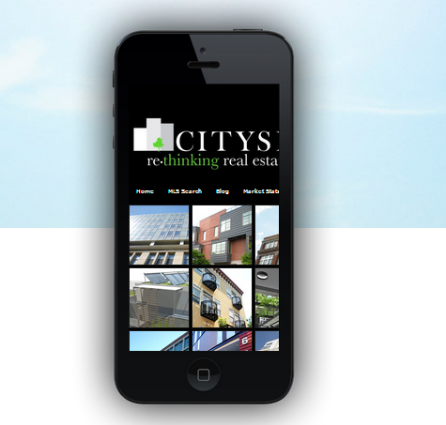

Your NEW Website On Mobile Devices
(after we finish our work)
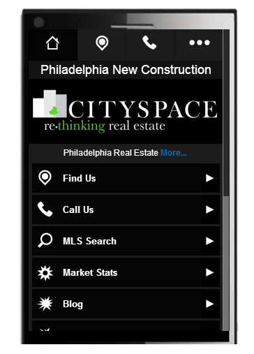

To order this mobile website NOW please
(payment)
($995 for development + $27 per month for hosting)
Your mobile website will be completed within 24 hours of receiving the payment.
If you have any questions please contact us
(818) 428-1411

