Reputation Marketing RoadMap
Reputation Marketing is a very hot topic. Most businesses do not even realize they have negative reviews online. Once a business owner sees that they have negative reviews floating around the internet, they turn into warm/hot leads and are ripe for the sale.
We provide unlimited LEADS in the CRM for Reputation Marketing. These leads have been prequalified, meaning they already have multiple negative reviews online. The goal is to let them feel the pain and then provide them with a solution.
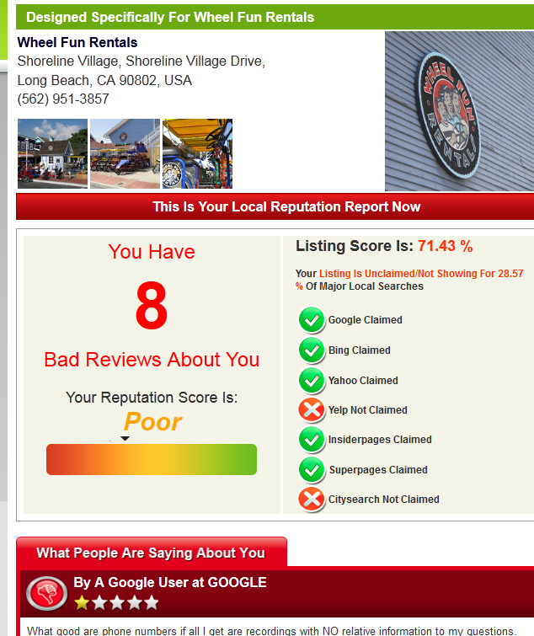
We have a proprietary system that will build a report based on the company’s bad reviews. You can use this in your selling in 2 ways. 1) You call the business and direct them to the link: RepVerification.com and they enter their phone number and they can see instantaneously) like above. 2) After talking to a business and getting their interest, you can send them a customized report. Send an email to repverification@mobilewebmds.com with the Client’s ID from the CRM and a link to the report will be sent to you so you can send out to the business owner. 3) You can now do this yourself. Just enter your name and email address so that the report goes directly to you. This will also provide you with a link to the report to email/send to the prospected customer!
As you can see, providing this information can be very compelling. If you owned a business and had several negative reviews all over the internet would you want to do something about it? Would you want to wait or would you want to start fixing it right away? …Exactly.
We will also build leads by sending qualified business owners to that website. They will fill in the information themselves. This is all tracked so we will be sending you emails with contacts of potential customers who have already seen the report for themselves. These should be considered super HOT leads because they have already taken the time to go to the site and request their free report on their own, which show huge interest on their part.
Go through the Resource section of the main website:
(http://www.MobileWebMDs.com/Resources) to find calling scripts, training and other helpful information.
This service sells for $2497 so the commission on each sale is a whopping $249 and qualifies for bonuses according to the bonus structures. Once a business owner sees that he/she has BAD reviews plastered all over the internet, they are more than likely interested in fixing this asap.
Sell the service, collect the fees and get your commissions!

Rinse & Repeat

