Once a business becomes a customer, you can provide them with the following URL:
http://mobilewebmds.com/Support/
They can create tickets, modify tickets and check tickets from the Support system.
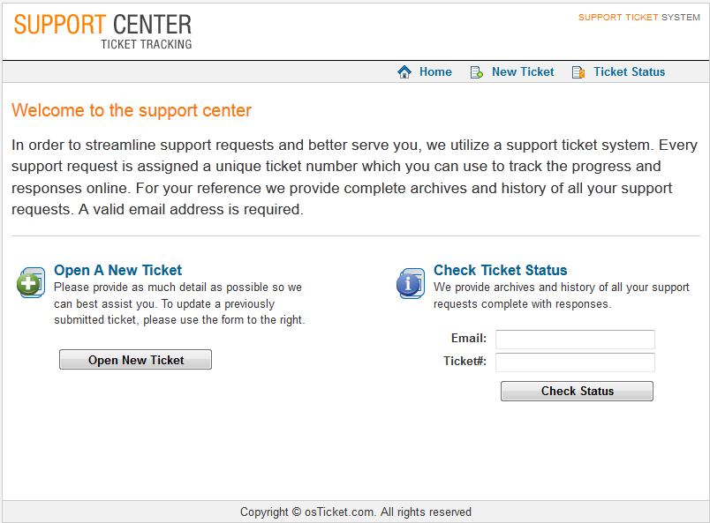
Our ticket responses differ according to the different services we provide so make sure you are up to par with all of our services and service levels.

