Responding to Mobile Website Customer Voicemails

You may receive voicemails from potential customers who were contacted via a recorded message. These may come to you in the form of email, with attached wave files, or emails with some basic contact info that was left in their message. Some will be removal requests, but the majority will be customers who are interested in out mobile website service.

Hi, may I please speak to (Name of person who left message)? I am returning his/her call.
If they tell you that person is not available, ask:
When would be a good time to reach him/her?
Can I have an email address that I can send some information to for him/her? (Hint: send Mobile Mockup)
If they ask to take a message, say something like:
Please let (Name) know that (Your Name) called from MobileWeb MDs returning his/her call about a mobile website. Here are my contact details (Phone number/email address, etc.)

If you got the person on the phone who you are trying to reach, proceed.
Hi Mr/Mrs Prospect. My name is (Your Name) and I work with a company called MobileWeb MDs, and I am returning your call. I understand you may be interested in a mobile website for your business? (Let them talk – just listen)

SINCE THEY ARE CALLING BACK FROM THE RECORDED MESSAGE, THEY MUST BE INTERESTED. TRY CLOSING THE SALE HERE!

Are you ready to get started today? YES = CLOSE THE SALE
NO? OR IF THEY NEED MORE INFORMATION, CONTINUE YOUR PROCESS:
Would you like to see a mockup of what your mobile website could look like?
OR
That’s great Mr/Mrs. Prospect, we have created many mobile websites for dentists (or whatever the industry/niche that the client is in) in the past AND by the end of this call, we will know for certain if we can help you.

The customer has already showed interest by calling us and leaving a message so we don’t really need to qualify them anymore. Proceed with an Opener or skip to Facts.

Openers
Did you know? Some facts about mobile: (Statistics/Quick 1 liners)(Know your stats! Study the infographics in the training and resource sections. The more knowledgeable you are the quicker you will build trust with the customer. Ex: How many smartphones are there in the US? How many people search using their phones, etc?)
- 90% of websites look horrible on a Smartphone. We can make sure you’re not one of them.
- Over 50% of all local searches happen on a Smartphone. Are you missing out?
- Google says that if your mobile website is hard to read, 61% of your audience leaves, and 40% goes to a competitor that has a good mobile web presence.
- What would you have to do to double your business this year? (Let them talk – just listen)

Facts
The fact is that people cannot get information about your business from their smartphone.. Were you aware of this problem? (Let them talk – just listen and respond to any questions they have)

We create a mobile-friendly website for you so that anyone trying to find out about you from a smartphone can find out everything about you quickly. Contact info, hours of operation, map and location, all the essential information customers are looking for. Can you start to see the benefits of having a mobile website? (Let them talk – just listen and respond to any questions they have)

I think we are a good fit for eachother. Would you like to proceed? (Let them talk – just listen and respond to any questions they have; they may ask about pricing here. Tell them we have a special this month, $997 and $47/mo to host/maintain the site / Prices/What’s Included are in the next few pages)
If they are on the fence or want to see more before closing the sale then offer a mockup.
Would you like to see a mockup demo of customized mobile website for your business? (If yes, create the mockup using the Mobile Mockup Method.) Follow up with them promptly and be consistent to get the sale!

Closing
You may not be able to close on the first call. If they want you to send them additional information or build a mockup for them, you will need to be persistent and follow up to get the sale. Here are some lines you can use or make up your own similar ones. “Mr/Ms. Prospect, what do you think about the before and after mockup I sent you?”“Are we ready to move forward?” “Can you see how much this is going to help your business?” “Let’s get you going before your competitors learn about mobile websites.” “All I need is 50% of the total today.” I can send you an invoice for the first half of the balance, and then we can collect the remainder of the balance when your mobile website is completed and online.” “How does that sound?”

No Sales
If they are not interested or the timing isn’t right, ask if you can send them some information. Let them know about the other services we provide: Mobile Web Apps, Push Messaging, Wordpress Security, and Reputation Marketing. Ask for a referral to someone who may need our services. Politely thank them and move on. If you feel they really wanted to something but the price may have been too high, discuss with your Sales Manager to see if we can come up with a customized option for them. Ask if you can follow up with them in a few weeks. Email them information to help educate them. Send them a link to here: http://www.mobilewebmds.com/why_mobile Leave your contact info. If the timing isn’t right today, it may be right next week. You never know!

Upselling
Once you make a sale to a customer, make a note to follow up with them in a couple weeks and see if they are interested in some of our other services, Web Apps, Push Messaging, Wordpress Security, Reputation Marketing, etc. Once you sell them something, it is 50-90% easier to sell them something additionally. And since we have built trust with them, we can show them why they need a Mobile Web App, etc.

Some Helpful Tips
The more calls you make, the more comfortable you will become. Just remember that you DO NOT want to sound like you are reading from a script. Once you put some of these ideas together to form your own personalized script(s), it will become very easy.

Spend some time making demo mockups to send to customers who seem very interested. You can get really good at this and create a mockup in about 2 minutes. Remember its just a demo mockup but it really paints a picture for the customer. It shows them something that they can see and relate to. It shows the pain factor (the before) and creates a need for them (the after). Using the Mobile Mockup Method with the Advanced Calling Script(s) can help skyrocket your sales! See the Mobile_Website_Mockup_Howto document for all the details on this option. ***If you don’t want to spend the time creating the mockups just send an email to mockups@mobilewebmds.com (with the Customer’s File ID# from CRM and one will be created and link sent to you/customer on your behalf within 60 minutes).

A good salesperson/closer can close 1 out of every 10 calls or so. The fact that the leads we are providing you are already prequalifying companies who do not have a mobile websites should help. These are not really considered cold calls, but warm calls since the businesses you are talking to already need our service (they don’t have a mobile website ((yet anyway)).

It’s a numbers game. The more customers you can talk to and educate in a day, the better your chance of sales.

Besides making the sale, your goal is to become this company’s trusted technology partner. If they trust you, they will want you to handle all of their technology needs!

Pricing for Mobile Websites
$997 and $47/mo (Hosting/Maintenance)
Tell them “We have a special price for the month of (current month) is $997 (regularly $1497). There is a $47 monthly fee which includes the hosting, maintenance, domain registration/renewals and any updates needed to the mobile website”. (If you get any customers, who complain about having to pay the monthly fees, or absolutely tell you they like the deal but will not pay the monthly fees, you can then let them know you can create the mobile website for them for $1297. This will waive the monthly fees, but it will not cover any hosting or domain fees. If they need any changes to the mobile website, they will need to contact us and we can discuss the fees. Also, if they choose the final pay option, all files will be delivered to them electronically with instructions so they can upload to the hosting/server of their choice. *(Keep in mind, there shouldn’t be many customers who complain about the monthly fees, but we don’t want to lose the sale if they do. Use caution when offering this $1297 no monthly fee option.)

What’s Included?
Mobile Websites for businesses ($997)
Professionally designed mobile website
Professionally re-designed header/logo
Mobile SEO optimized
Click to Call
Google maps integration
Up to 10 pages (Home, About Us, Contact Us, Services, etc)
Contact form
Redirect script
Customized domain
Custom QR Code
Monthly - $47/mo which includes up to 3 changes to the content and hosting for the website. Support is email based and 24-48 hour response time.
*Monthly maintenance is required. (Exception: $1297 final pay option)
*Turnaround time is 14-21 days to completion.
*Ecommerce is not included. If you find a customer interested in a store-based website to sell products/services, we can get back to them with a custom quote.

If they need a Company Website AND a Mobile Website
$2497 and $67/mo
Tell them “We have a special price for the month of (current month) is $2497 (regularly $3497). There is a $67 monthly fee which includes the hosting, maintenance, domain registration/renewals and any updates needed to both websites”. This deal is only good with the $67 maintenance fee included. If they need a business website and a mobile website, and are already complaining about the monthly fee, take down their details and let them know you will get back to them with a price shortly. Then discuss with your Sales Manager asap.

What’s included?
Business Website AND Mobile Website Package - $2497 and $67/mo
Company Website:
A Professionally designed template for your niche
Up to 5 pages of content (Home, About, Contact Us, Services, etc)
SEO optimized pages
Contact form
Map integration
Domain research/registration (if needed)
Mobile Website:
Professionally designed mobile website
Professionally re-designed header/logo
Mobile SEO optimized
Click to Call
Google maps integration
Up to 8 pages
Contact form
Redirect script
Customized domain
Custom QR Code
Monthly - $47/mo which includes up to 3 changes to the content and hosting for both websites. Support is email based and 24-48 hour response time.
*Monthly maintenance is required. (Exception: $1297 final pay option)
*Turnaround time is 14-21 days to completion.
*Ecommerce is not included.

Use the Advanced Script Ideas and the Traditional Call Scripts to customize the best script(s) that make sense for the customer and work best for you. Remember to pre-qualify them by asking open-ended questions and listening to what they have to say. Give them answers that can help them. Educate them as to why they need our services.
Traditional Call Script for calling a business (Old way of selling but some points are still useful)
Hi, Can I speak with the person who is responsible for your website please...
Objections:
What’s it concerning? The person you want isn't here? We are perfectly happy with our website thank you! What are you selling? We have a website!
Response -
This will only take a minute and doesn't cost anything; I tried to access your website from my iPhone and I have a tip for you:
- It’s very difficult to get information from your website on my mobile phone.
- Your website is built in Flash, and doesn't load on my iPhone. (Broken Website leads)
- I can't read your text - it's too small
- Your images are too big and can't load
- Your PDF menu is hard to read
- I can't open your menu on my phone

Objection:
My web company takes care of this. We don’t need this right now thank you. I don’t have time to talk right now. Can you please send me something by email?
Response -
I want to explain. Our mobile websites are specialized. We don't focus on normal websites, only for visitors coming from mobile phones - that’s how everyone searches these days anyways.
Did you know that over one half of all local searches are performed on mobile devices? And you are really missing out if these customers can’t get information from your website.
Response -
Answer - Really? I didn’t know that?....
"I work with a company that will create a custom mobile version of your current website, specifically made for all smartphones. I can send you a link for more information. Can I have an email address?
Send a personalized email to them immediately after the call and make a note to follow up in 1-2 days.
(See Email Template below)

Another script for calling a business
Hi, I was trying to access your website from my phone and found it difficult because [PROBLEM].
I work with a company that has built many mobile websites for businesses in [CITY], and I can confidently tell you that you’re missing out on a massive mobile marketing opportunity. This is different from regular websites Cellphones are on pace to become the number one way people access the internet, especially for restaurants and bars, because before people go to them, they may try to find out the specials, hours,
menus, etc. on the go from their phones, not computers. CLOSE – Is this something you might be interested in?

*Highlighted – OPTIONAL
Another script for calling a business
Did you know that there are X searches per month for the terms [BUSINESS KEYWORDS] every month from mobile phones. This is right from Google. You see, Google is so smart they automatically rank businesses that have mobile website much higher if they have mobile optimized websites. CLOSE – Is this something you might be interested in?
*Do a little research. If you are calling an Italian Restaurant in Los Angeles, do a Google search for Italian Restaurant Los Angeles using the Google Keyword External Tool and it will tell you how many searches happen every month for that search term.

Some helpful tips:
* If you are calling leads that have a main website, see how it looks on the mobile web simulator so you can have a personal idea of their needs.
* Educate them as much as possible. If they can understand that they are losing potential business because they don’t have a mobile website, then they are more likely to buy.

*Become familiar with all the resources on the website. Use these to help educate potential customers.

*Once you build trust with a client, introduce them to other services we provide. We would like to partner with you for all of your technical needs…

*There will be rejections and hang ups. It is part of the business. It is a numbers game. The more you can educate the more you will sell. If you get NOs. thank them for their time and ask if you can send info via email and/or ask if you can call them in a couple weeks. Always give them the option to get back to you.

* It may take more than a couple calls/emails to get the sale. The key is persistence and consistency. Follow up, follow up, and follow up. Leave messages; follow up with a call and/or email.

Mix and match the above scripts to suit your style and needs.
Remember, nothing is going to happen until you take ACTION!
Email template 1 (No Mockup):
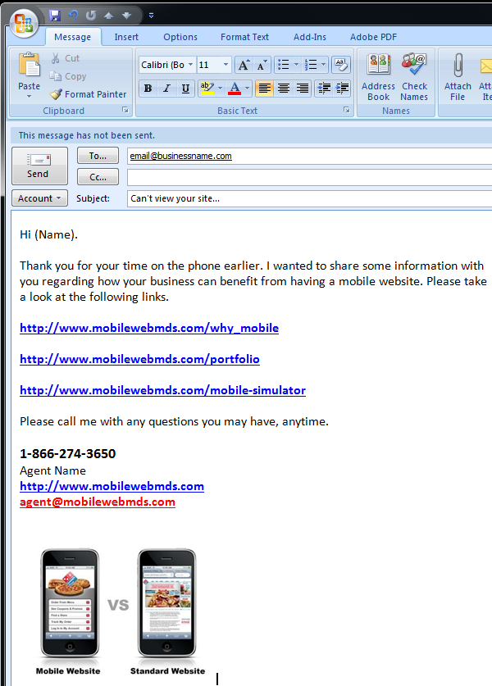

Email Template #2 (Mobile Mockup Included):
