Mobile Website Mockup How To

The idea here is to show potential business owners what their current site looks like on a mobile phone, and what if COULD look like if they had a mobile website. This works better if you start a conversation with the customer first. “Can I send you a mobile mockup of your website so you can see what it would look like?” “May I have your email address so I can send you some important information about your website?” “I can send you a mockup that shows you the benefits of having a mobile website”. Work these in with the basic call scripts and spend a little extra time creating a mockup and you should have a much higher closing rate. Also, use this mockup option if the customer is very interested but needs/wants more information, or is on the fence, undecided…
Let’s take this lead for example – http://losaltosdental.com (Dentist)

1. Go to the site and quickly browse through it.
2. Go to the following link to start the mobile mockup tool:
http://www.mobilewebmds.com/Sales-Agents/USERNAME/mmm/admin
(USERNAME will be sent in your welcome email along with your password.)
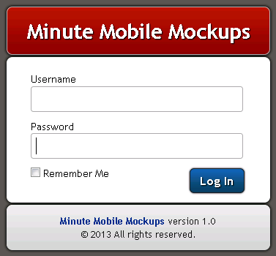

3: Create New Mockup
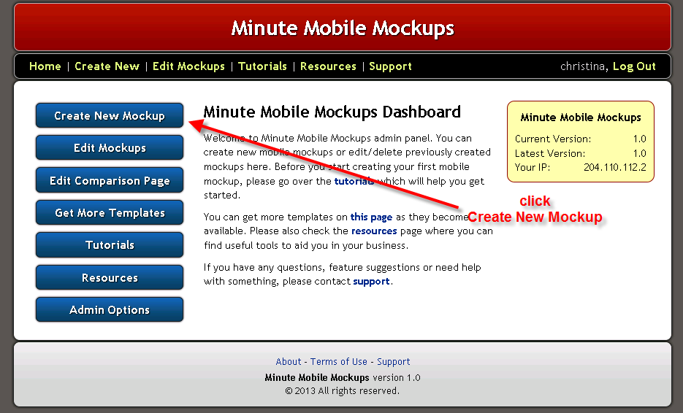

4. Next Select the Niche (In this case we are targeting a Dentist – but if the Category doesn’t exist for a different lead you are working with, for example, Roofer, then choose Generic)

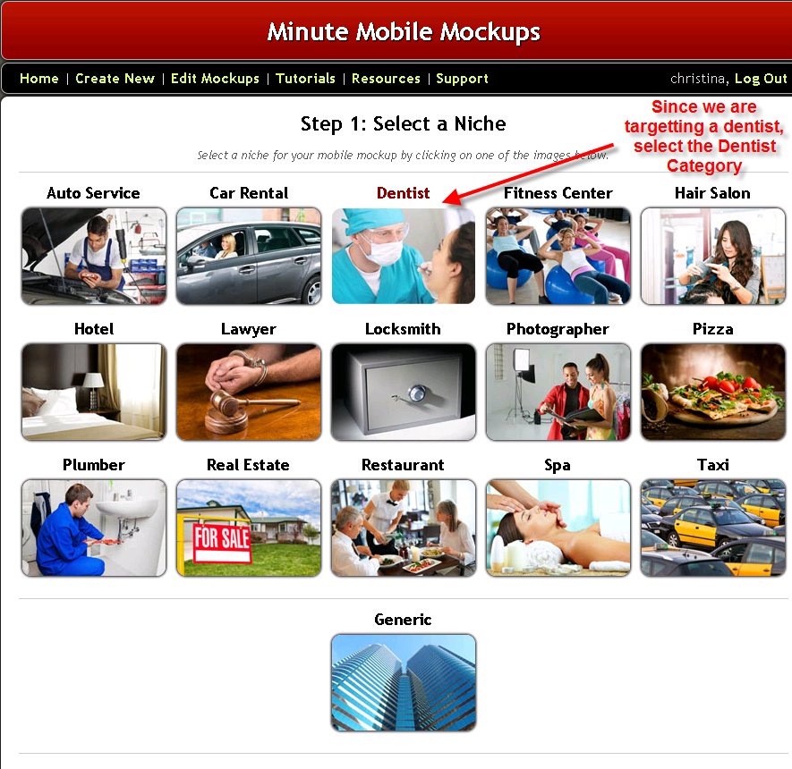

5. Select Jump Mobi Basic or My Mobile Business Template

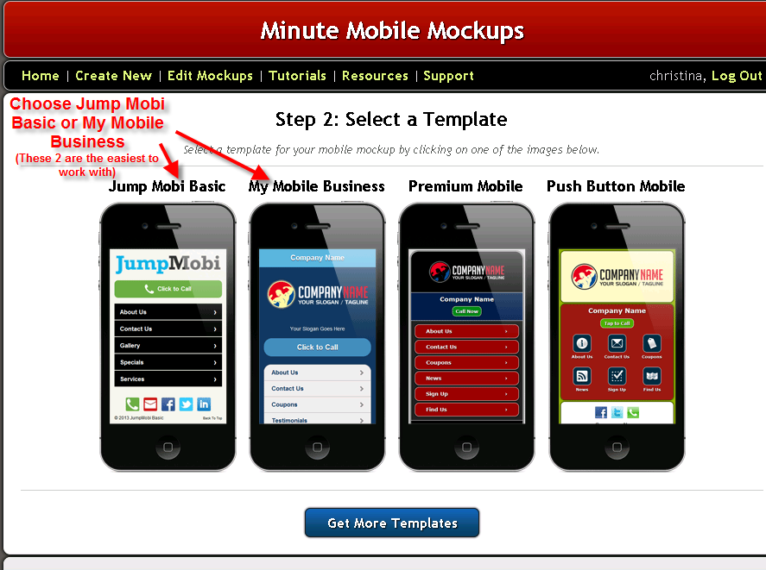

6: Fill in as much detail about their business as you can. Take this info straight from their website.

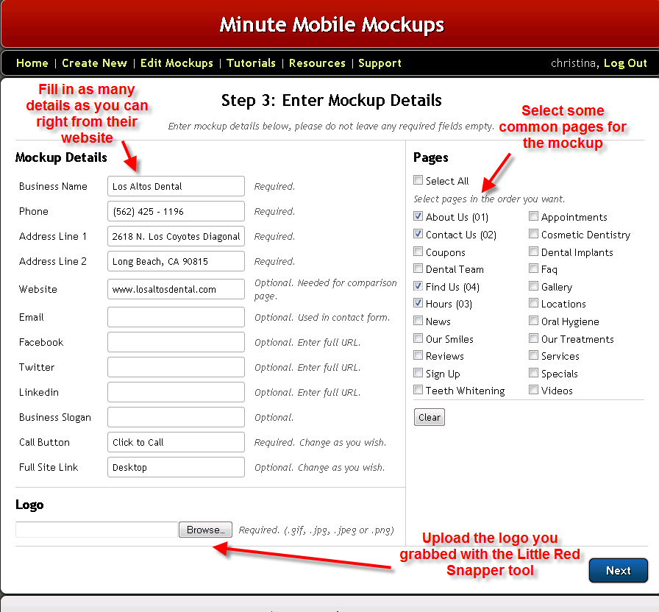

7. Use the Little Red Snapper tool to grab a copy of their logo and upload it under the Logo section.

You can download the tool from here:

http://www.mobilewebmds.com/Tools/LRS-V1.0.3-WIN.zip

Go to File – Snap and draw a box around the logo.
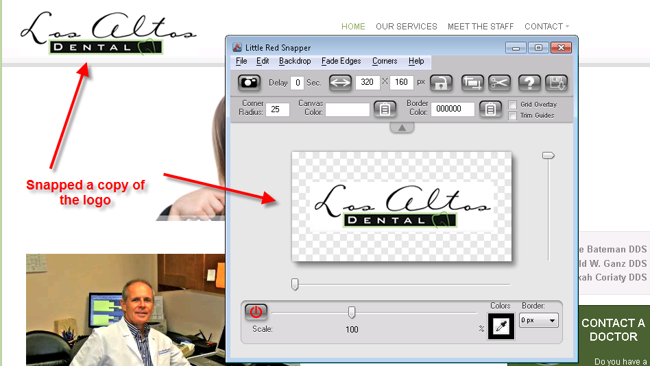

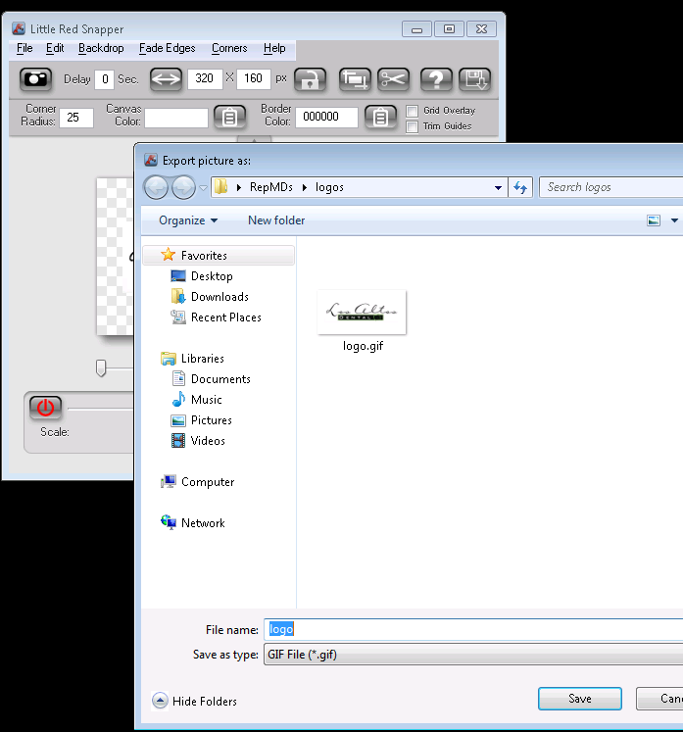

Once you click File – Save, it will ask for a location to save to. Create a new folder to save all your logos.

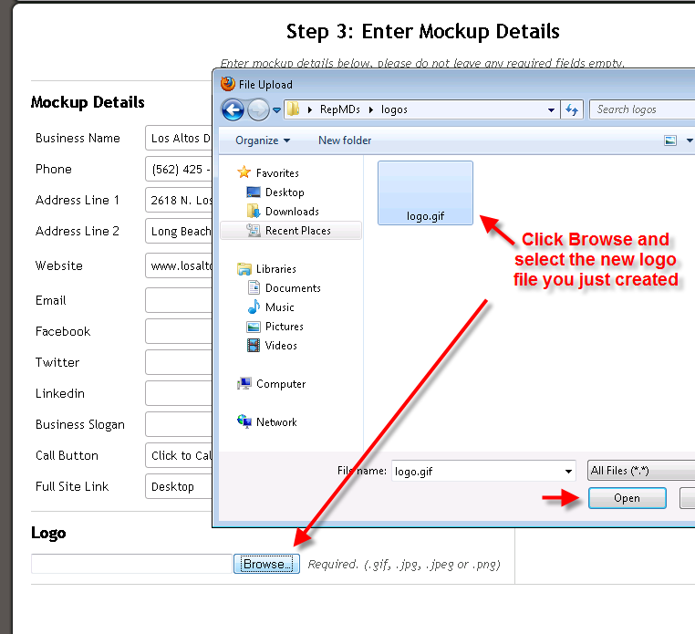

This will be the logo image that you upload under the Logo – Browse (Bottom left of the Enter Mockup Details page.)

8. Change the colors to match their current website as best as you can. You want it to look pretty close so they will recognize the colors on their mockup site.

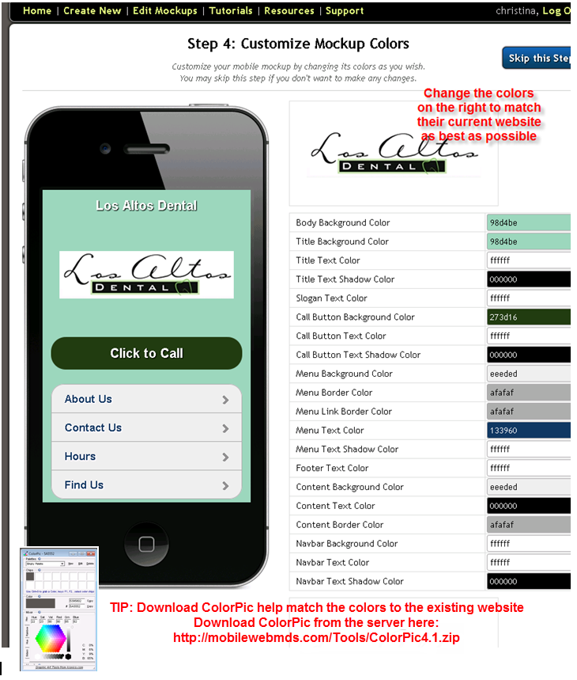

9. Now that your mockup is finished, you have a link that is ready to send to the potential client.

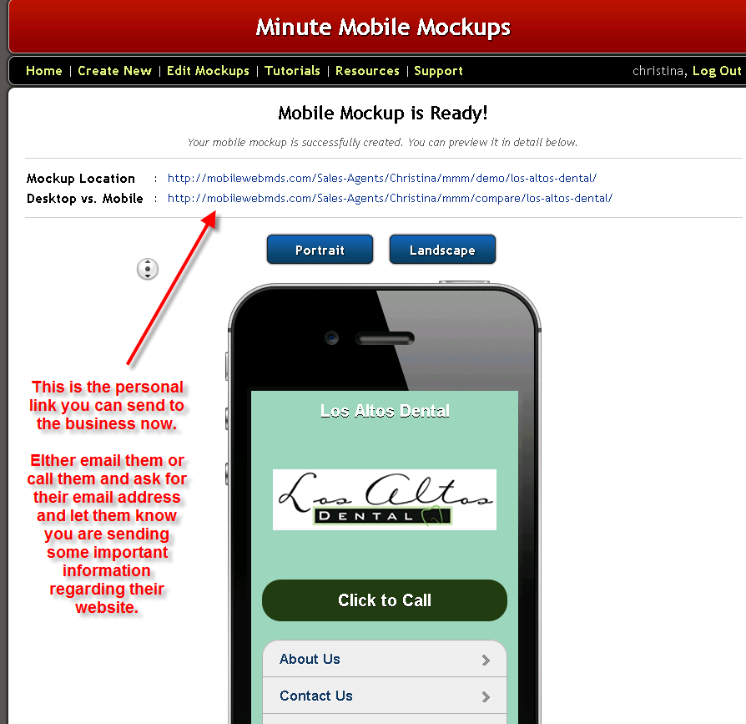

This is a perfect selling model to show the potential customer. A before and after, an informative video and contact form all on one page! Now that they can actually see something concrete, it will be pretty hard for them to refuse, especially if they understand the importance/benefits of having a mobile-friendly website.
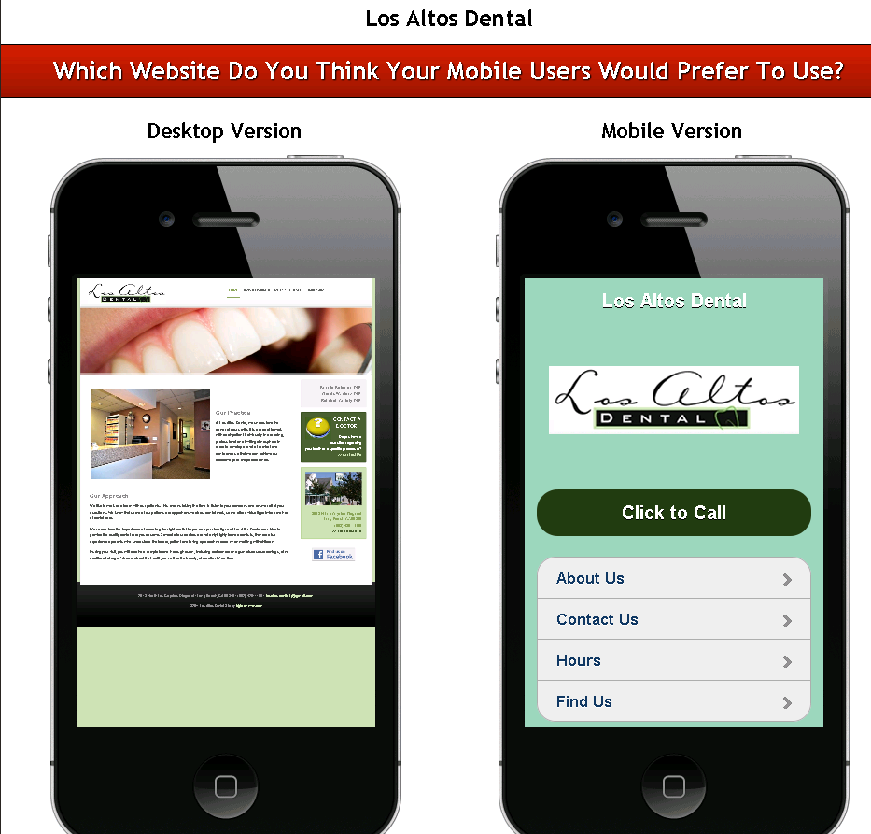

Use this link in your email campaigns, when corresponding with your potential clients, and when you are on calls. Educate them on how important it is to have a mobile website, tell them the stats, etc and then show them the mockup. This should be an easy sell!

If you are sending these without talking to the potential customer first, each demo page has a contact form so they can get back in touch with you.

There are no limits to the amount of these mockups that you can create. Just keep in mind that these are meant to be demos only. You can edit them as needed.
With a little practice, you can create a full mockup in a couple minutes. Usually giving them something they can actually see will get you much further than if you are just making calls. So use this option in addition with your calls and email campaigns.

Remember they may not purchase on the first try. The key is to follow up as much as possible.

***If you don’t want to spend the time creating these mockups just send an email to mockups@mobilewebmds.com (with the Customer’s File ID# from CRM and one will be created and link sent to you/customer on your behalf within 60 minutes).

If you prefer to spend your time hammering out phone calls full time, then take advantage of having the mockups created for you. That way you can focus on the volume of phone calls you need to make for the day.

There is no limit to the amount of mockups you can request. We can hammer them out pretty quickly and get them to the customers you are talking to within an hour or less. (Usually a few minutes) You will be cc’d on the email to the customer so you can follow up with the customer and close the sale.

Good luck!

Remember, nothing is going to happen until you take ACTION!

Mobile Website Mockup Sample Email Template:
