How to Use the CRM
The CRM is the database add, store and track our customers in. You will receive your login information in your Welcome Email. Once you have your Username and Password you can log in here:
http://www.RepMDs.com/crm
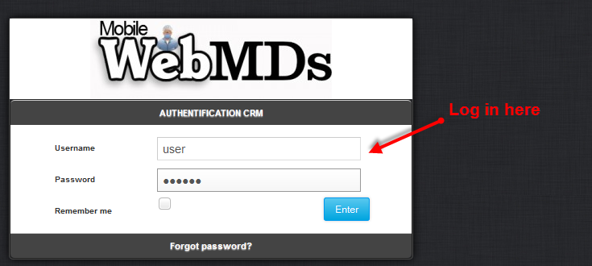

Hint: Make sure you use Firefox or Chrome. Do not use Internet Explorer!

Once logged in, you will see this screen. These are the clients you have added to the CRM. You can Add Clients, Edit Clients and Send Invoices from this screen.
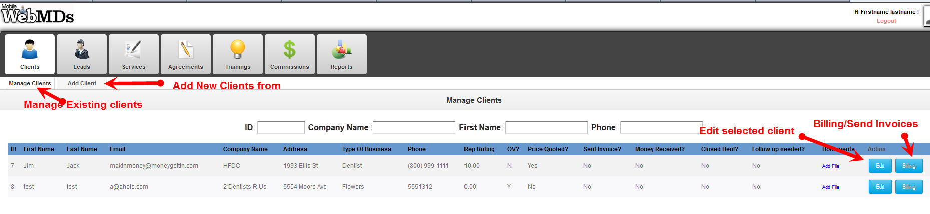

Once you select a client and click Edit, you will see a screen like this:
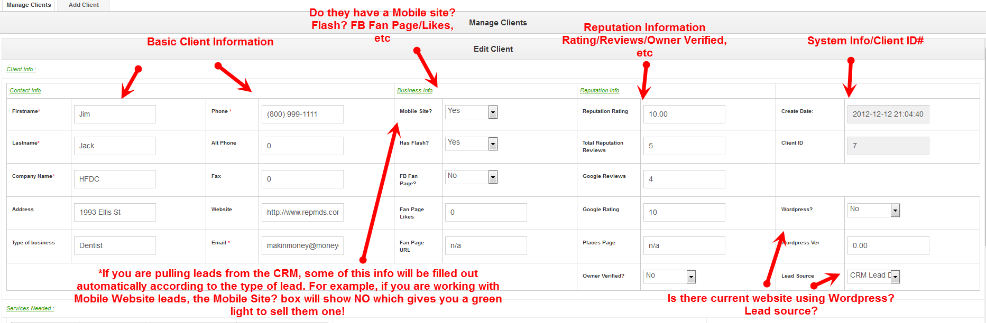
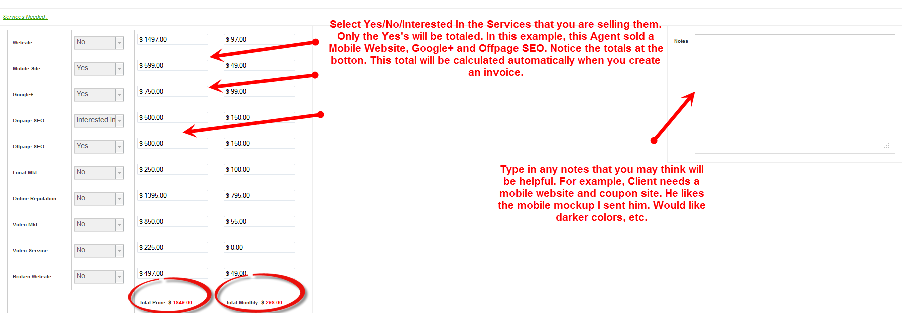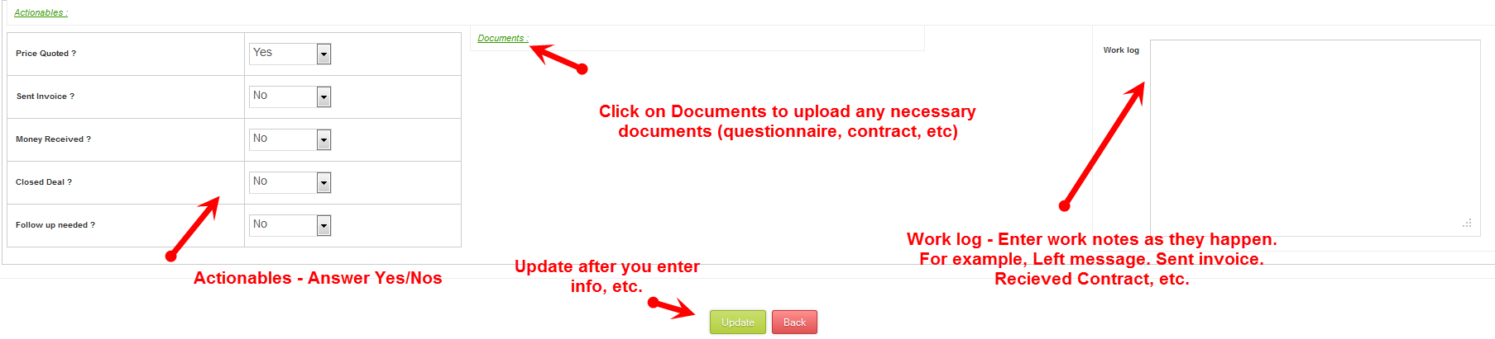

LEADS:
Your Sales Manager will determine which leads you have access to. The buttons will be available based on your permission access. Find the Leads you want to work on here:
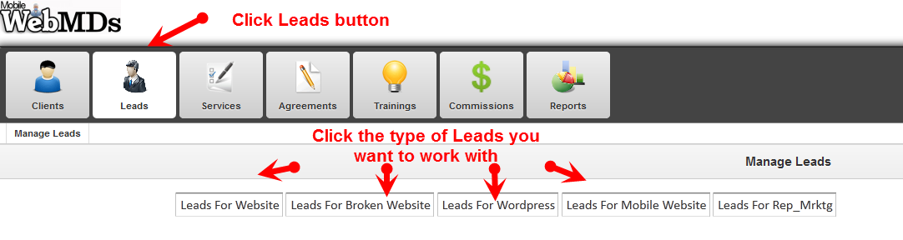

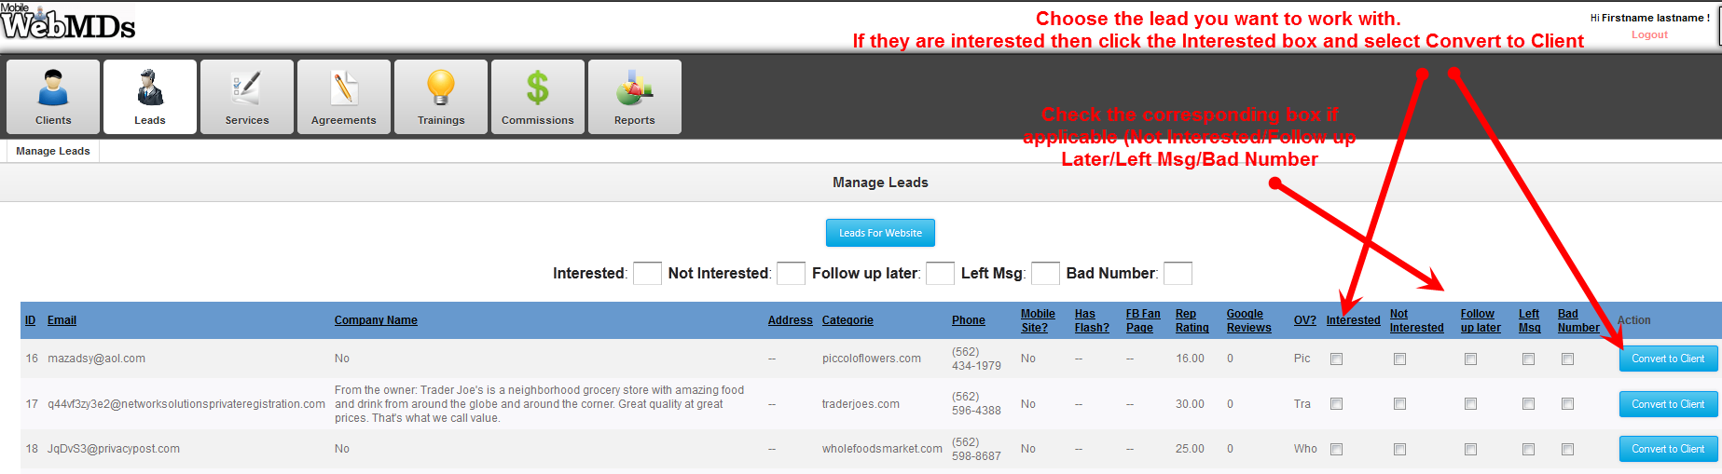
After you click Convert to Client you should see this: 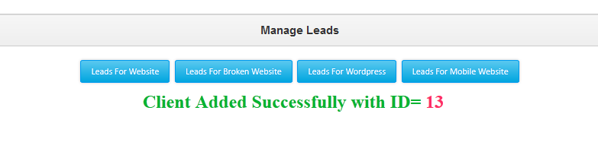
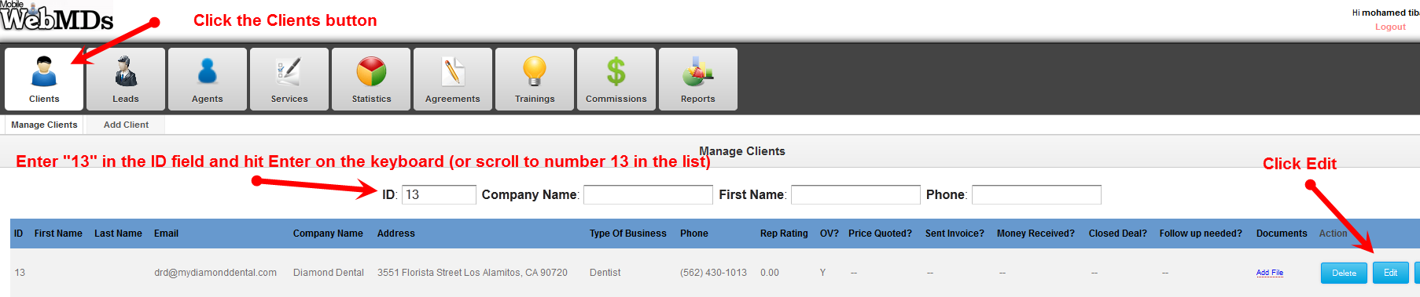
Once you click Edit, you will see the Customer’s file. You can enter in the information that is not populated automatically. Fill in as much info as you can.
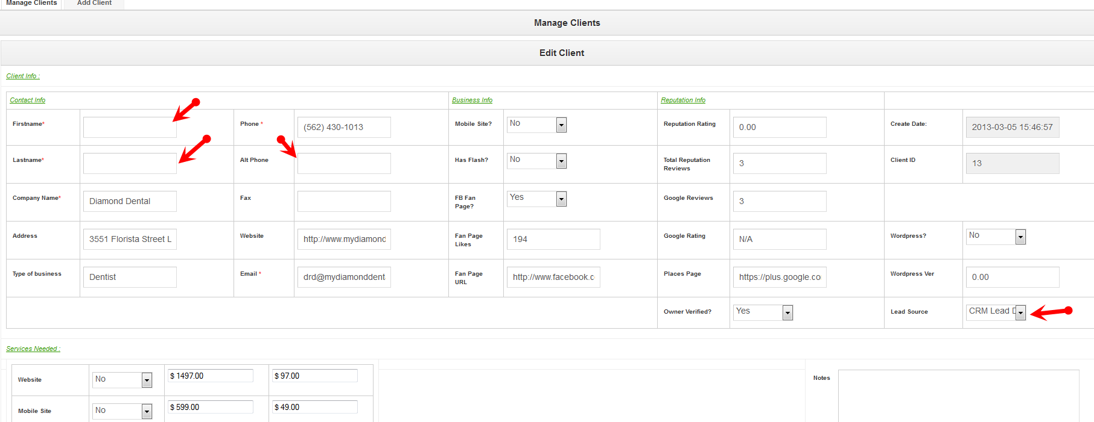

Select the service the customer is interested in:
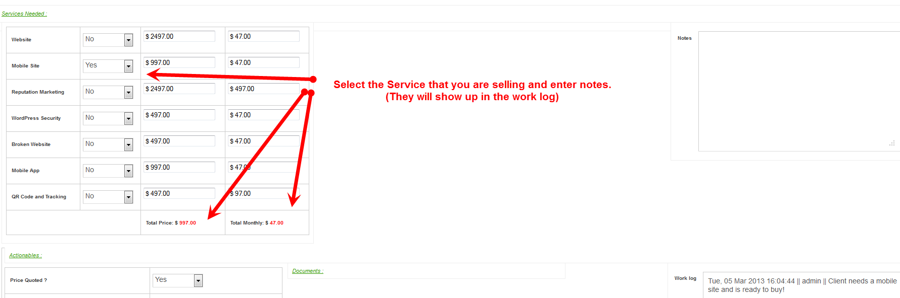
Click any options that are applicable
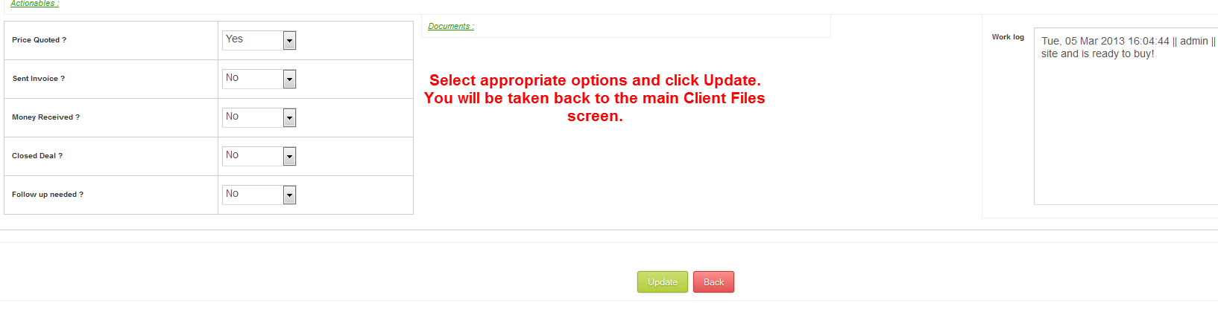
If you need to add files to your customer’s record:
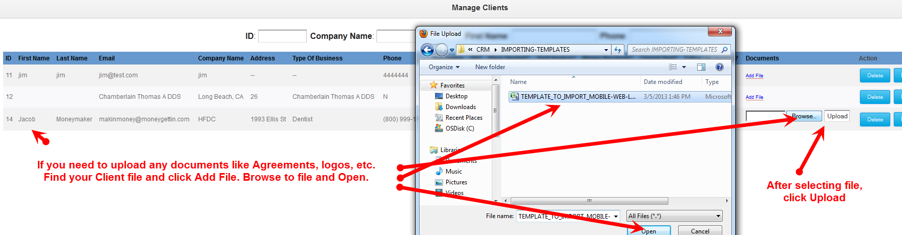
Repeat the process for multiple file uploads. The uploaded files will be stored in the Client’s record:
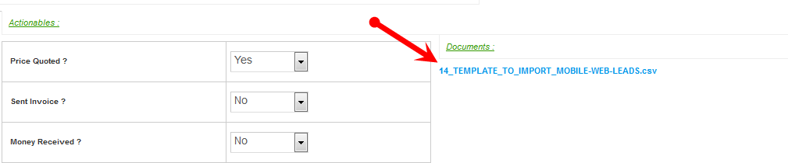
And here:
To create an invoice for the Client, Select the Client from the main client panel and click on Billing:
