How to Invoice and Collect Payments from Customers
Once you have closed a sale, the preferred method of invoicing and collecting payment from customers is to generate the invoice directly from the CRM. In the customer’s file, there is a button to generate either a 50% (50% of total) invoice, or a full (100% of total) invoice. From here, it will send a link to them so they can pay via Paypal. That is our preferred method.
We understand that not everyone has a Paypal account or wants to pay online. So the alternate option is to send them an invoice via email (create within the CRM) and let them send a company/personal check to us. If this is the option they want to use, they can send payment to:
DevelopingRiches, Inc.
2892 Bellflower Blvd
Ste #312
Long Beach, CA 90815
If they choose this option, make sure they send a copy of their invoice with their check. Also, let them know that it usually takes about 5 business days (after we receive it and deposit it) to clear payment with the bank. After the check clears, we will start working on their order.
We are working on accepting checks over the phone (check by phone), credit cards over the phone and electronic check. These services should be available in the next few months.
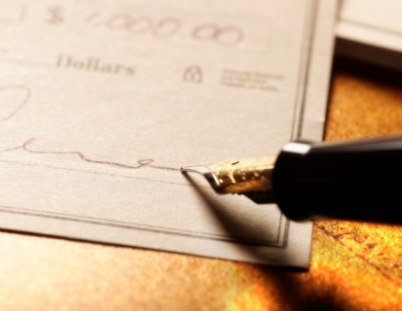
Remember it is important to track payments and stay on top of your sales. Sales Agents and Sales Managers do not get paid their commissions until at least 50% of the total order is received. That’s why we try to make Paypal the preferred option. Money is available immediately, and commissions can be processed quickly.
If the customer does not have a Paypal account, they can sign up for one for free or use Pay with a Credit or Debit Card option without signing up for an account.
Go make some money!

